Jade Pearl
COSC 320-001 Lab 11: Graph Minimization 4/30/2023

Lab report: I authorize that what was done in this lab is my own work. I finished this lab in approximately 2 hours.

Pre-lab:
- Review the materials we learned for short paths and spanning trees
- Perform minimum path algorithm for graph B
  - From A to E: A B C D F E with weight of 22

Files Created:
lab_11.cpp, graphB.dat

Lab 11:
- Read and copy d_graph.h and “d_util.h” which will be used in the program
- Write a program named lab_11.cpp
  - It will ask user to input one of the vertices from graph B. For each of the other vertices v in the graph, the program will determine the weight of the minimum path weight
  - It will then output the vertex that has the largest minimum-path weight, the weight of the minimum path, and the path itself
- Compare answers with the sample output:
  - 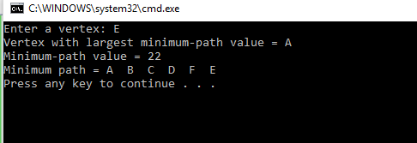
Source Code:
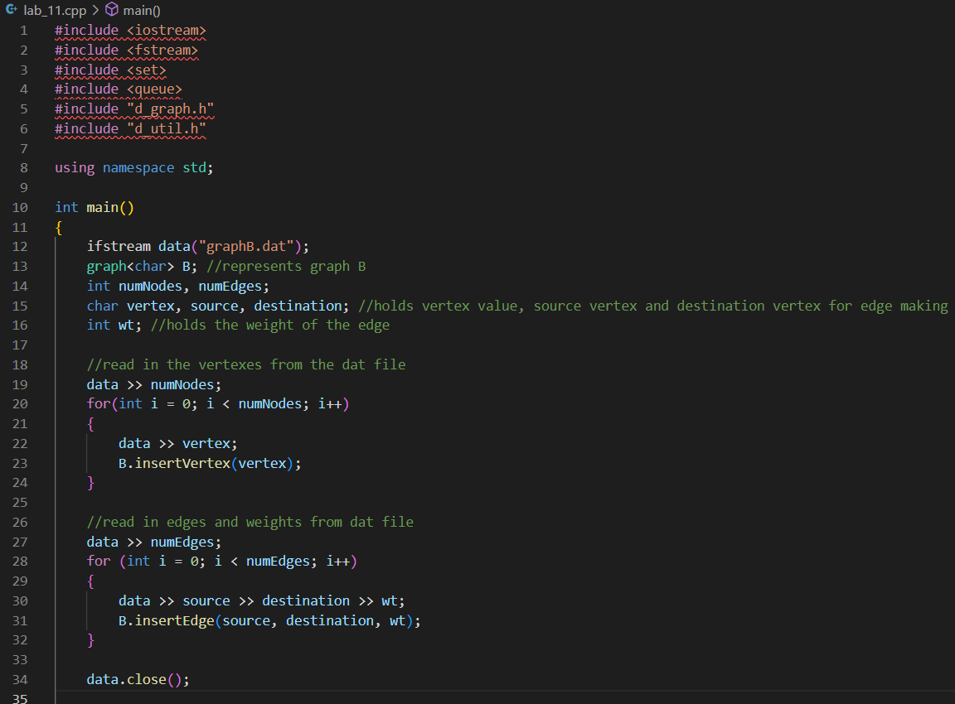
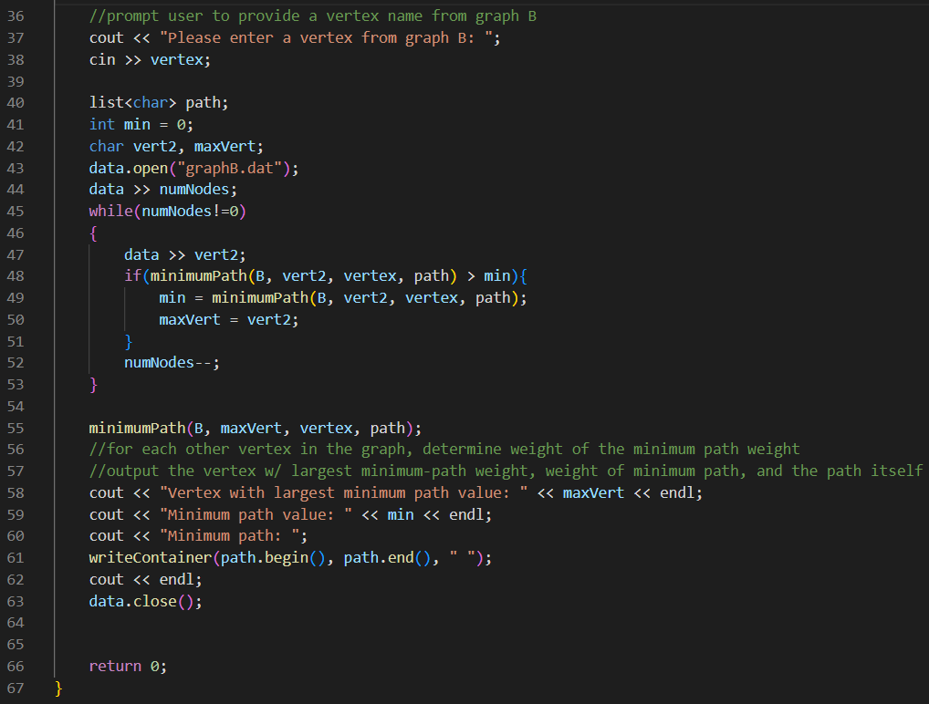
Sample Outputs:
